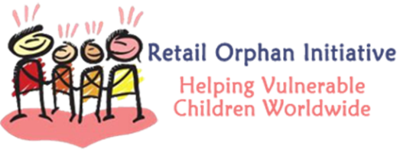

Together we make a difference….
Two Clean Water Wells in Ugandan Villages thanks to
the RetailROI and Share The Blessings partnership.

“Webale, Webale, Webale!”, that’s what we heard during a visit recently with Fr. Joseph Ntuwa whose childhood village, Kyamabaale, now has a clean water well. These “thanks” are expressed with such joy, enthusiasm and gratefulness for a gift that is life changing and life giving for those who visit the well several times a day for water to drink, cook and stay clean with.
This past year two new wells were dug in Ugandan villages thanks to the work of RetailROI and Share The Blessings.
Kyamabaale, Buddu near Kibiinge, Bukomansimbi District. It is about 12 miles from Masaka Town. The well will serve 30 Households and there are 5-8 orphans in each household; children living with extended families. The water situation was really pathetic - the source which is down the slope is shared by both human beings and animals. Ms Justine Kazibwe, a responsible woman leader who is the Chairperson of the Women’s League in this village, will be responsible to run and maintain this well. Each household will contribute a minimal fee for maintenance.
Naalya-Nansese Local Council near Bujuuko, Muduuma Sub-Parish, Mpigi District. It will serve 30-45 Households and two schools. There are 50-60 Orphans in this community. The community was getting water from down deep in the valley. This water is too dirty and contaminated. During drought season, villagers move long distances to look for water. People seriously suffer a great deal while looking for water. Peter Tebusweke, born in this village and now a seminarian, along with his family will be responsible to run and maintain this well. Peter is teaching the local people how to operate the well to avoid mishandling and hopes to have the villagers pay some money to maintain funds for the well.
Through mutual support RetailROI and Share The Blessings have helped hundreds of orphans in Uganda through educational programs and what is now four clean water wells. Here is a link to pictures from both villages: https://www.dropbox.com/sh/yq9kis37vg1lti6/ISc1DO2wR2
The Purpose of the Retail Orphan Initiative (RetailROI; www.retailroi.org) is to raise awareness and provide real solutions for the more than 400 million vulnerable children worldwide. Share The Blessings (www.share-the-blessings.org) continues to focus on two main goals clean water and education.

