Share the Blessings Sponsorship Levels

- Non-Boarding Primary School Students: $150/year $12.50/month

- Non-Boarding Secondary School Students: $300/year $25/month

- Boarding Secondary School Students:
$450/year $37.50/month

- Boarding Tertiary/Seminary Students:
$450/year $37.50/month

Other Options:
- I want to make a one-time STB Education donation of: $

- I would like to make a general contribution to STB: $

Name:

Address:

City, State, Zip Code

Email: Phone:

Please complete and mail with tax-deductible donation to:
Share the Blessings, Inc.
P.O. Box 3024 Cary, NC 27519
Human Dignity
Since 2002, Share the Blessings has committed itself to two major goals in the developing world: providing clean water through the construction of village wells and raising funds to help children stay in school. Working with Fr. Joseph Kakooza, a Catholic priest of the Diocese of Kasana-Luweero in Uganda, we have focused our education efforts on a group of primary, secondary and tertiary students known as the “St. Francis Group.” These students have lost one or both parents to AIDS, war or other causes, reducing their family’s ability to pay their school fees. Through the generosity of our donors, Share the Blessings has been able to cover tuition fees for over 50 students during the past five years. The success stories are heartening:
- St. Francis students have pursued post- secondary studies in vocational / teacher colleges and Ugandan universities.
- St. Francis graduates are now working as carpenters, electricians, plumbers, tailors and nurses.
- St. Francis graduates are Catholic seminarians who hope to serve the Church as priests.
How it Works
- Fill out the form on the right, choosing the sponsorship level you would like to commit to. Return this form with payment to the address listed at the bottom.

- Share the Blessings will send you an information packet on your sponsor student with the student’s name, picture, and background information.

- The student will be given your name, and both sides are encouraged to pray for each other.

- There will be letter exchanges on an annual basis. All letters will be processed through Share the Blessings Cary, NC address. We will not distribute your email, home address or other personal information to students in Uganda.

You will receive an annual notice with a request to continue support. Sponsoring a student is a year-by-year decision: you are not committed beyond 12 months at any time.

Sponsorship payments will support the Share the Blessings general education fund and the St. Francis group. All payments will be distributed through Share the Blessings and are tax-deductible.

You will be forever changed by interacting with a child living in a world so different than yours. Knowing a name and seeing a face connects you in a way that no other opportunity, short of going to visit yourself, can give you. By sharing what you have, you will be blessed.
Uganda education facts:
- Average pupil to teacher ratio (primary school): 52 to 1

- Percentage of children who complete primary school (grades 1–7): 56%

- Percentage of children who transition from primary to secondary school: 37%

- Percentage of children who drop out of secondary school due to lack of fees: 62%
Rev 05/19

From our students …

“I would not be what I am without you. I suffered at first but now I am enjoying my right to education. I will study hard to make you happy.”
Namugambe Mary Gorret

“I greatly thank you for the effort you apply in the interest of supporting me in almost all affairs of life. This is based on the fact that you have supported me in education which is a foundation for the rest and a major determinant of one’s future. I have my parents, but they are old and they can’t support me at school.
Economically they are poor.”

For more information, please contact:

education@share-the-blessings.org

Share the Blessings Student Sponsorship Program

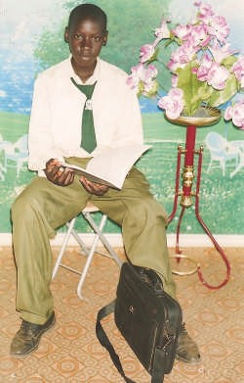
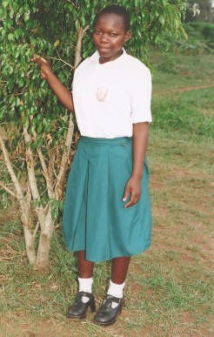
Kabalimu James

“I am sad to inform you that I do not have parents because they died of AIDS in 2002 when I was still in primary school. I had no one to help me, but when you trust God you cannot regret at all because he is a provider and controller of all things on the planet. By financing our education, you have saved us from this chaotic world of needy people. We are now enjoying life and education, and abundant thanks goes out to all of you.”
Kaweesa Ssessanga

“I love you so much because you have helped me to study. Thank you very much. I will not forget you in my prayers.”
Arinaitwe Lillian

Share the Blessings, Inc.
P.O. Box 3024 Cary, NC 27519

www.share-the-blessings.org

Share the Blessings, Inc. is a recognized non- profit organization under section 501 (c)( 3) of the Internal Revenue Code, FEIN 14-1882445.

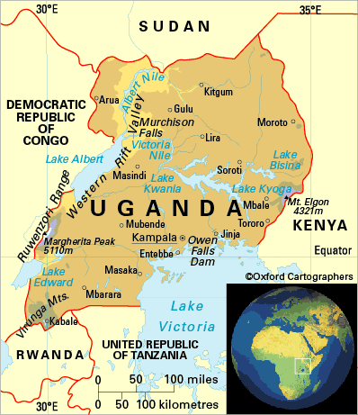

Share the Blessings “Providing basic human needs and dignity for all through prayer and
acts of love.”

