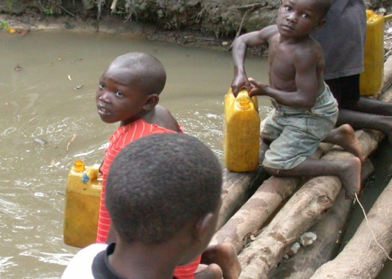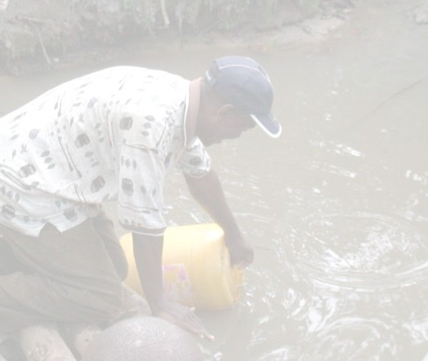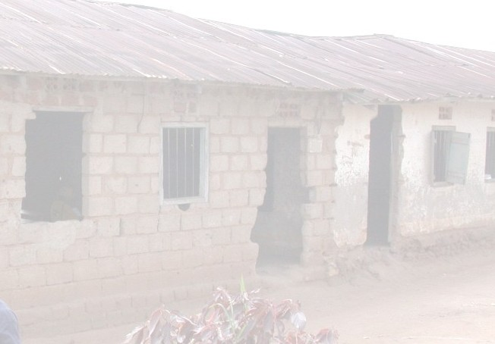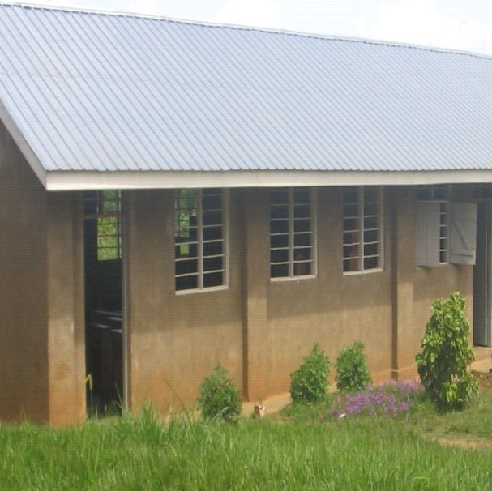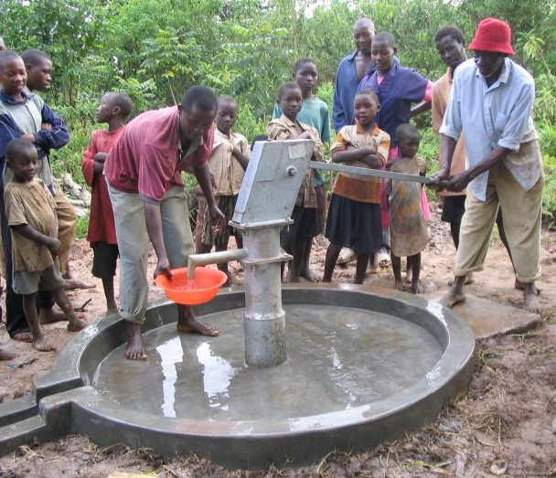
Our Beginnings
In July 2002, a small group of Catholics traveled with Fr. Emmanuel Katongole on a cultural exchange trip to Uganda. During their visit to Fr. Emmanuel’s village, the group accompanied villagers to their only water source,
a muddy pond about a mile from the village. The fact that these people were lacking one of humanity’s basic needs, clean water,

which we take for granted, had a profound impact. Similar experiences also occurred during visits to schools and orphanages around Uganda. Upon returning, the group began gathering monthly to
share their
experiences. This
resulted in the
addition of several
people who had
profound direct
experiences of need
in other Majority
World countries. This culminated in the desire to form a more permanent organization that would educate people to the needs of our brothers and
sisters in developing countries and to provide assistance for those in need. Thus far we have shared our blessings with people in Uganda
and Bolivia.
Share
The Blessings
Clean
Water
Education

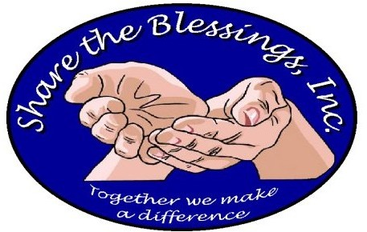

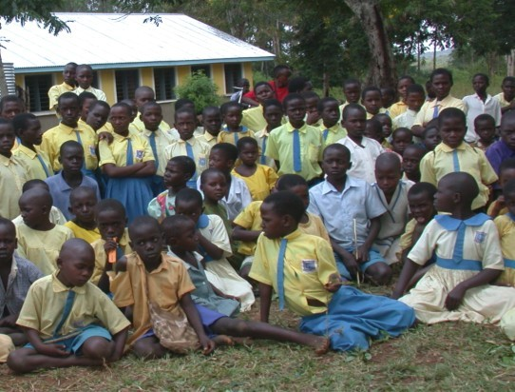
www.share-the-blessings.org
919-324-8936

Share the Blessings, Inc.
PO Box 3024
Cary, NC 27519

Share the Blessings, Inc. is a recognized non-profit organization under section 501(c)(3) of the
Internal Revenue Code, FEIN 14-1882445.

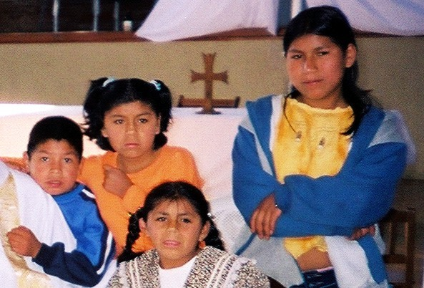

Share the Blessings’ Goals

Clean water for drinking, for cooking, for washing,
….....for LIFE.
Share the Blessings’ goal is to fund at least two wells per year. These may be deep wells or shallow wells, depending on the local hydrology. Deep wells cost
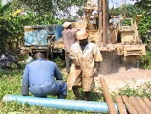
about $10,000. Shallow wells cost about $5,000. New wells have been built
in various Ugandan schools and villages… bringing clean water to hundreds of people. Plus, because local contractors were used, the funds help to improve the regional economy.
Education for the mind, for the heart, for the soul,

….....for LIFE.
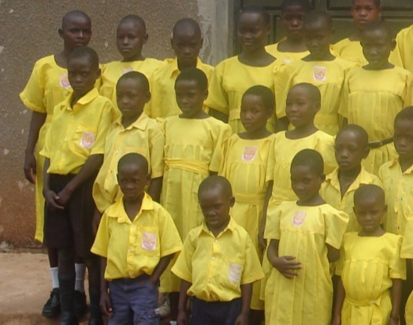
Share the Blessings’ goal is to provide education tuition and support for children each year. Approximately $300 will provide education for one child for a year and an additional $150 will supply room and board.
Over 700 children, many whom were orphans, have received support
for their education. Plus, several school buildings have been renovated and over 50 computers have been placed in schools for student and teacher use.

HOW CAN I HELP?
You can help us achieve our goals in many important ways; through your prayers, your time, and your donations. Please complete this section and return it to Share the Bless-
ing with your offer to help. God bless you.
Name
Address
Phone
Email
Return to:
Share the Blessings, Inc. PO Box 3024
Cary, NC 27519
- I will pray for Share the Blessings.
- I want to help Share the Blessings. Please find enclosed my check for $ .
- I want to help provide Clean Water. Please find enclosed my check for $ .
- I want to help provide Education. Please find enclosed my check for $ .
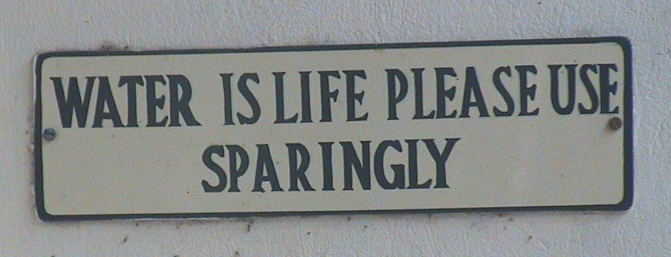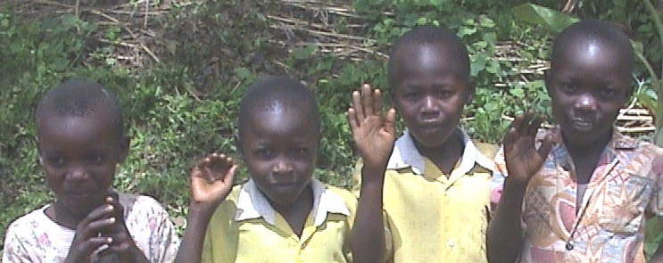
Rev 05/19

